**Introduction**

Dudepanda is a simple ecommerce marketplace of bakeries located in karachi. Customers can save themselves from the hassle of going to the bakery and buying items rather place an order through this website and get it delivered directly to their place like ordering a birthday cake for their loved ones.

The following report attempts to list down the steps taken in order to create this project. The members who’s efforts pulled off this project are Hasan Naseem, Faraz Ozair and Hozefa Haider.

The website required a database which would essentially contain the data of All the Vendors, Customers, Food items, Orders etc. So the first job was to decide and create an entity relationship diagram (ERD) that would form the basis of our Database.

**ERD;**

Following is a picture of our ERD;

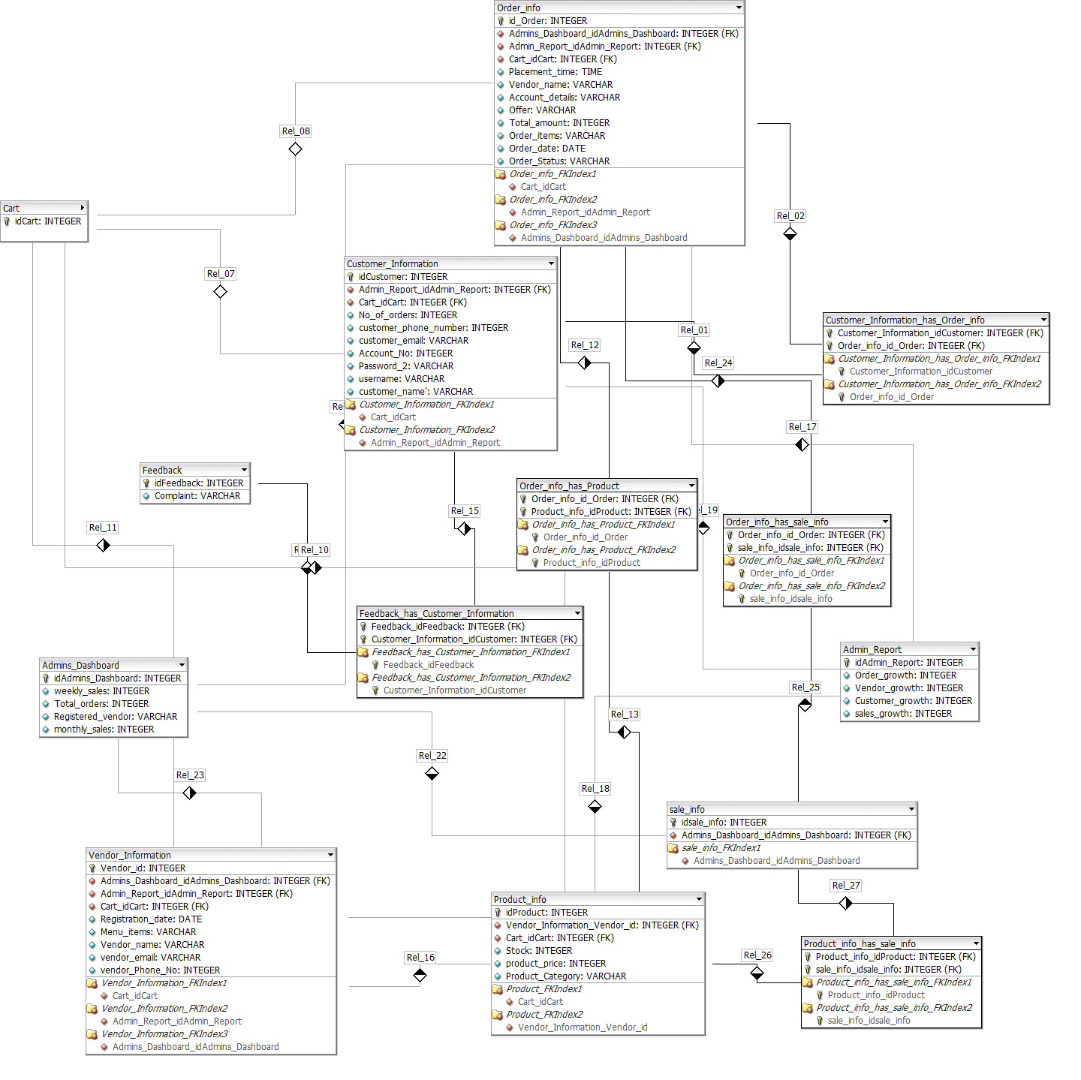

The entities in this ERD are **Admins Dashboard, Vendor Information, Customer Information, Admin Report, Product_Info, Cart,Order_Info, Feedback**

Following is the description of the entities and the relationships between them:

-**Admins Dashboard**;

This Table will show the registered Vendors and the Total number of Orders, weekly and monthly sales, of these Vendors both of which will be derived from daily sales(which itself- will be a derived quantity, sum of sales of a particular day). This table will allow the admin to have an overall picture of the Vendor Performances which will be reflected by their Orders and Sales and also reflect the Company’s performance as well.

-**Vendor Information**

This table will contain the list of Vendors registered with the Company. Each Vendor has certain attributes such as Vendor name, phone no#, Registration date etc. Each Vendor is assigned a Vendor ID by the Company

- **Customer Information**

Customer info will contain the details of the users that have signed up on the website whether or not they use the application or not. This table contains the users account details (account# , password, username) and other details such as phone number, email address and of course the name of the Customer. Each Customer is assigned a Customer ID by the company at the time when the Customer creates an account

-**Admin Report**

Admin Report and Admins Dashboard are related to each other in the sense that both of them give an overall picture of the Company’s Performance. However the table of Admin Report gives a more concrete and statistical analysis of the Company’s Performance as the attributes it holds are essentially all in numbers; Order growth, Vendor growth, Customer growth, sales growth.

-**Product Information**

Product Information will display the Menu of the Different Vendors. Each Product is assigned a Product ID by the Company

**-Cart**

Each Customer will have its own Cart (and hence a seperate ID assigned by the Company) which will hold information about the order.

-**Order Information**

This table will contain the information about the details of a particular order placed by a customer, including its placement time. Each order will have a distinct ID assigned by the Company.

-**Feedback**

Customers will be reviewed about their experiences regarding their usage and satisfaction. This table will contain all that data

**Relationships:**

-**Admin Dashboard**

* 1:n relationship with Order_info table since the admin will have access every order information from the customer. E.g. quantity, item name, item ID etc. Similarly, many order informations will be managed by the same admin.
* 1:n relationship with Sale_info table since every sale done of a particular item will be managed by the admin and a single admin will have many sale_info at a particular time. Similarly, many sales will be managed by the admin as well.
* 1:n relationship with the Vendor_information because the admin will also have many vendors at a particular time and he will be managing all the vendor items and will have the vendor information incheck with him. Similarly, many vendors could have the same admin.

-**Vendor Information**

* 1:n relationship with Product_info table since the vendor would have the information of the product he is giving to the company. Therefore, the vendor will have information for many products at any given time and many products could have the same vendor.
* M:n relationship with Cart since 1 vendor information could be in many different carts and 1 cart could have many different vendors in it.

-**Customer Information**

* M:n relationship with Order_info table since the customer should be aware of what he is ordering and what is the price and quantity of what he is ordering. Hence, a customer could have many orders and vice versa.
* M:n relationship with Feedback table since the customer may have many feedbacks and same feedback may also be given by many customers.
* 1:n relationship with cart since 1 customer could have many carts in a day if he orders multiple times and many carts could be of the same customer as well.

-**Admin Report**

* 1:n relationship with Order_info table so that the admin could include order information in his weekly report. Many order informations could be input in the weekly report and similarly, 1 report may contain many order informations.
* 1:n relationship with Customer information as well since the report may contain information for many customers and also many customer informations could be included in the same admin report.
* Similarly, 1:n relationship with Vendor_information table since the report would contain which product was given by which vendor as well so a single report would contain many vendor information. And many vender information could also be in a single report since different products could be sold by different vendors.

-**Product Information**

* M:n relationship with Sale_info table, single product could have many sales and similarly 1 sale could be of many products.
* M:n relationship with Order_info table, 1 product could have many orders and similarly 1 orders could be of many different products.
* M:n relationship with Cart since many products could be in a single cart and many carts could have one product as well.

- **Order Information**

* M:n relationship with Customer Information since one order could be placed by many customers and one customer could place many orders as well.
* M:n relationship with Sale_info table since one order could have many sales and one sale could be of many orders.
* M:n relationship with Product_info since one order could have many products and many products could be in one order.
* M:n relationship with Cart since 1 cart could have many orders in it and many carts could contain the same order.

-**Feedback**

* M:n relationship with Customer information since 1 customer could have many feedbacks and 1 feedback could be given by many customers as well.

-**Cart**

* M:n relationship with Product_info table since many products could be in a single cart and many carts could have one product as well.
* M:n relationship with Vendor_info since 1 vendor information could be in many different carts and 1 cart could have many different vendors in it.
* M:n relationship with Order_info since 1 cart could have many orders in it and many carts could contain the same order.

**Environment For Database:**

The environment used for Database is Prestashop, which is an open source E-commerce solution, which can be used to run stores in the cloud or via self-hosting. It is currently used by 250,000 shops and is available in 65 languages. Prestashop is fairly easy to use and provides a powerfully responsive store interface for shoppers, offers a comprehensive set of features for free.

**Setup for Prestashop:**

* **What you need to get started:**

Here is a list of things which are required before you proceed to download Prestashop.

* System requirements:
  + PHP 5.4 or later.
    - Useful settings (in the php.ini file):
      * allow_url_fopen set to On,
      * register_globals set to Off,
      * upload_max_filesize set to "16M" (or more).
    - Must-have PHP extensions (in the php.ini file): PDO_MySQL, cURL, SimpleXML, mcrypt, GD, OpenSSL, DOM, SOAP, Zip, fileinfo.
    - Useful server tools: cron/crontab, Memcached.
  + MySQL 5.0 or later.
  + Better if:
    - Unix/Linux hosting.
    - Apache Web Server 2.0 or later or nginx Web Server.
      * Apache module settings:
        + mod_rewrite enabled,
        + mod_security disabled,
        + mod_auth_basic disabled.
    - At least 128 Mb of RAM dedicated to PHP. The more the better.
* Access codes to your FTP server, your MySQL database
  + These should be provided by your web host if you are not doing a local installation.
* Any text editor.
* Any FTP client.
* Any modern Web browser (if using Internet Explorer: at least IE9).

(taken from <http://doc.prestashop.com/display/PS17/What+you+need+to+get+started>)

* **Prestashop Setup:**
  + Download zip file for Prestashop version 1.7.6.2, which is available on its website, i.e. <https://www.prestashop.com/en/download>.
  + Use Xampp, which is a free and open-source cross-platform web server solution stack package developed by Apache Friends, consisting mainly of the Apache HTTP Server, MariaDB database, and interpreters for scripts written in PHP and Perl programming languages. After installing Xampp, we will start Apache and MySQL module. Now, our local host is available for use.
  + Now, when you type <http://localhost/phpmyadmin> on your web browser, it will open your local host database. Create a new database with name, “prestashopdb” from the Database tab.
  + Now, when you type <http://localhost/prestashop> on your web browser, it will start the installation setup for Prestashop.
  + Follow the steps and input details as required.
  + During the steps, when it asks about the database_host, database_name, database_user and database_password, type the details of the database you created on phpmyadmin.
  + As soon as you complete the steps, it will give you the generated links for both, prestashop customer hand and prestashop admin panel.
  + You can edit the shop according to your product through the admin panel, such as logo, products, themes, carousel, pictures etc.
  + You can also manage the orders, shipping, sales and over all performance of the store through the admin panel.

**- Prestashop Admin Panel:**

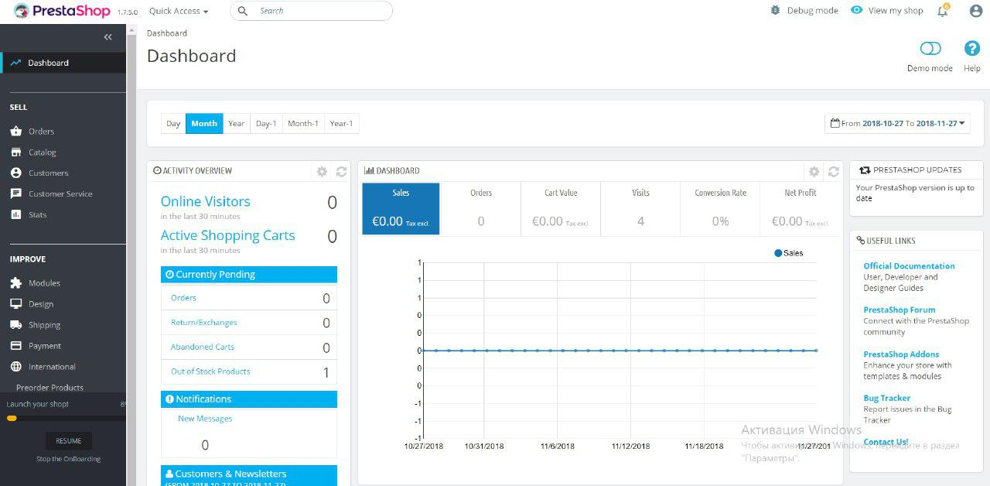

Sample data: